Road Extraction from Satellite Images using DeepLabV3+

S A Sharan Veronica, Kaviyarasu K ,Dr. Santosh Kumar J

UGstudents, Computer Science and Technology, Dayananda Sagar University, Bengaluru-562112

Abstract

This project presents a deep learning-based approach for the extraction of road networks from satellite images using the DeepLabV3+ model. The primary goal is to facilitate efficient road detection for urban planning, disaster management, and navigation systems. The proposed solution leverages a ResNet50 backbone with pre-trained weights for feature extraction and semantic segmentation. The methodology includes preprocessing the satellite images, model training on labeled datasets, and evaluating the segmentation results using metrics such as Intersection over Union (IoU) and Dice Coefficient. The results demonstrate the model's ability to accurately identify road segments, paving the way for scalable and practical solutions in geospatial analysis.

Keywords:

Introduction

Road extraction from satellite imagery is a crucial task in geospatial analysis and urban planning. It plays a significant role in applications such as autonomous navigation, disaster management, traffic monitoring, and infrastructure development. The availability of high-resolution satellite images and advancements in deep learning have enabled researchers to develop automated techniques for accurate road detection and segmentation. Traditional manual methods for road extraction are time-consuming, prone to human error, and infeasible for large-scale operations. With the advent of advanced deep learning architectures, semantic segmentation models like DeepLabV3+ have emerged as effective solutions for extracting roads from complex satellite images.

DeepLabV3+ integrates the strengths of encoder-decoder architecture and atrous spatial pyramid pooling (ASPP) to capture both fine details and global context. This makes it well-suited for identifying road networks, even in challenging scenarios such as urban clutter, shadows, or vegetation obstructions.

### Key Points in the Introduction

#### 1. Significance of Road Extraction

* Essential for urban planning and infrastructure development.
* Supports disaster management by identifying accessible routes during emergencies.
* Facilitates autonomous vehicle navigation and real-time traffic monitoring.

#### 2. Challenges in Road Detection

* Complex backgrounds like shadows, buildings, and vegetation.
* Occlusions caused by natural or man-made structures.
* Variations in road width, color, and material across regions.

#### 3. Role of Deep Learning

* Deep learning models have revolutionized computer vision tasks by enabling automated, efficient, and scalable solutions.
* Semantic segmentation models such as DeepLabV3+ achieve high accuracy in extracting pixel-level road features.

#### 4. DeepLabV3+ Model Overview

* Combines atrous convolutions for multi-scale feature extraction with an encoder-decoder architecture for accurate predictions.
* Captures global context and local details effectively, making it ideal for road segmentation.

.

#### Automating Road Extraction

The primary goal of this study is to develop an automated system for detecting and segmenting road networks from satellite images. Traditional methods, which rely on manual or semi-automated techniques, are labor-intensive, time-consuming, and unsuitable for large-scale applications. By leveraging the capabilities of deep learning, specifically the DeepLabV3+ model, this project aims to significantly reduce the time and effort required for road extraction, while improving accuracy and consistency.

#### Utilizing DeepLabV3+ for Satellite Imagery

DeepLabV3+ is a state-of-the-art semantic segmentation model that has proven to be effective in extracting features from high-resolution images. The model is trained on labeled datasets of satellite imagery, allowing it to learn and predict road patterns, even in challenging environments with occlusions, irregular road widths, or natural obstructions such as trees and shadows. This study explores the potential of this model to handle diverse geographical regions and varying satellite image qualities.

#### Performance Evaluation

The performance of the road extraction system will be evaluated using metrics that are crucial for segmentation tasks. These include:

1. Accuracy: The percentage of correctly identified road pixels compared to the ground truth.
2. Intersection-over-Union (IoU): Measures the overlap between predicted road pixels and actual road pixels, providing a robust assessment of the model’s segmentation performance.
3. Efficiency: Assesses the computational speed and resource usage of the model, ensuring it is viable for real-world applications, including real-time analysis in disaster or traffic management scenarios.

Problem Definition

Manually identifying roads from satellite images is a tedious and error-prone process. The complexity increases with factors such as:

* Poor image resolution or inconsistent lighting conditions.
* Occlusion from trees, vehicles, or buildings.
* Lack of generalization across different geographic regions.  
  This research aims to address these challenges by building a robust, automated road extraction system using deep learning.

Literature Review

Road extraction from satellite images is a critical research area in computer vision and geospatial analysis, significantly enhanced by the integration of deep learning. Below is an overview of existing approaches and advancements:

#### 1. Traditional Approaches

Early methods relied on:

* Edge Detection (e.g., Canny, Sobel): Useful for identifying road boundaries but sensitive to noise.
* Thresholding Techniques: Classified roads based on pixel intensity, but struggled with shadows and occlusions.
* Mathematical Morphology: Enhanced road features using dilation and erosion but lacked robustness for diverse terrains.

Limitations: Handcrafted features, low scalability, and poor performance under varying conditions.

#### 2. Machine Learning-Based Methods

* Supervised Learning: Models like SVMs and random forests classified roads using labeled data (e.g., Mnih and Hinton, 2010).
* Unsupervised Learning: Techniques like K-means clustered road-like features but lacked generalization.

Limitations: Required extensive feature engineering and failed to capture spatial relationships.

#### 3. Deep Learning Approaches

Deep learning models excel at learning hierarchical features from data:

* Fully Convolutional Networks (FCNs): Pioneered pixel-wise segmentation but struggled with fine details.
* U-Net: Used skip connections to retain spatial details; performed well in structured urban areas.
* DeepLabV3+: Enhanced multi-scale context and refined outputs using atrous convolutions; a leading model for road segmentation.

#### 4. Hybrid Approaches

* Post-Processing: Morphological operations and graph-based methods refine road connectivity.
* Graph Neural Networks (GNNs): Emerging tools to enhance road network topology.

#### 5. Challenges

* Road Variability: Unpaved or occluded roads in rural areas.
* Class Imbalance: Roads occupy a small fraction of satellite images.
* Computational Costs: Training on high-resolution images is resource-intensive.
* Limited Data: Annotated datasets are scarce for certain regions.

#### 6. Benchmarked Datasets

* SpaceNet: Widely used for road extraction tasks with high-quality annotations.
* DeepGlobe Road Dataset: Designed for training and evaluating road segmentation models.
* Deep learning-based approaches, particularly DeepLabV3+, represent the current state-of-the-art in addressing the complexities of road extraction from satellite imagery.

Existing and Proposed

Existing Solutions:

Existing Work:

* DeepLabV3+ is a state-of-the-art deep learning model used for semantic segmentation tasks, including road extraction from satellite imagery.
* Key Features:
  + Uses atrous convolutions (dilated convolutions) to capture multi-scale context, enabling better handling of roads of varying widths.
  + Encoder-decoder architecture with skip connections to retain spatial resolution and improve segmentation accuracy.
  + Excellent performance in complex environments, capturing fine details of roads, even in urban or rural settings.

Proposed Solution:

Enhancing DeepLabV3+ for Road Extraction:

* Data Augmentation: Apply techniques like rotation, cropping, and flipping to increase the variety of road types in the dataset and address class imbalance.
* Post-Processing: Use morphological operations or graph-based methods to refine road connectivity and smooth segmentation boundaries.
* Fine-Tuning: Fine-tune the model on region-specific datasets (e.g., rural, urban, or remote areas) to improve accuracy in diverse environments.
* Hybrid Approach: Incorporate Graph Neural Networks (GNNs) to better capture the geometric relationships between roads and enhance the overall road network connectivity.

Requirements

#### 1. Hardware Requirements:

* High-Performance GPU:
  + Necessary for training deep learning models like DeepLabV3+ on high-resolution satellite images. Recommended GPUs: NVIDIA RTX 3090, Tesla V100, or equivalent.
* Sufficient RAM:
  + At least 16 GB of RAM to handle large datasets and the training process efficiently.
* Storage:
  + Large storage (SSD recommended) for storing satellite images, datasets, model weights, and intermediate outputs. Around 100 GB or more depending on the dataset size.

#### 2. Software Requirements:

* Operating System:
  + Linux (Ubuntu) or Windows. Linux is generally preferred for deep learning tasks due to its compatibility with most libraries.
* Deep Learning Framework:
  + TensorFlow or PyTorch (TensorFlow is commonly used for DeepLabV3+).
* Python:
  + Python 3.6+ for scripting and model training.
* CUDA and cuDNN:
  + For GPU acceleration, install CUDA and cuDNN compatible with your GPU and TensorFlow/PyTorch version.
* Libraries:
  + NumPy for numerical operations.
  + OpenCV or PIL for image preprocessing and augmentation.
  + Matplotlib for visualizing results.

#### 3. Dataset Requirements:

* High-Resolution Satellite Images:
  + Annotated images with ground truth road data (e.g., SpaceNet, DeepGlobe).
* Data Preprocessing:
  + Image Resizing: Resize images to a fixed resolution (e.g., 512x512 or 1024x1024 pixels).
  + Label Encoding: Roads are labeled as foreground (1) and background (0).

#### 4. Model Requirements:

* Pre Trained DeepLabV3+:
  + Use a pre trained DeepLabV3+ model as a starting point to avoid training from scratch. Fine-tune it on your specific dataset for better results.

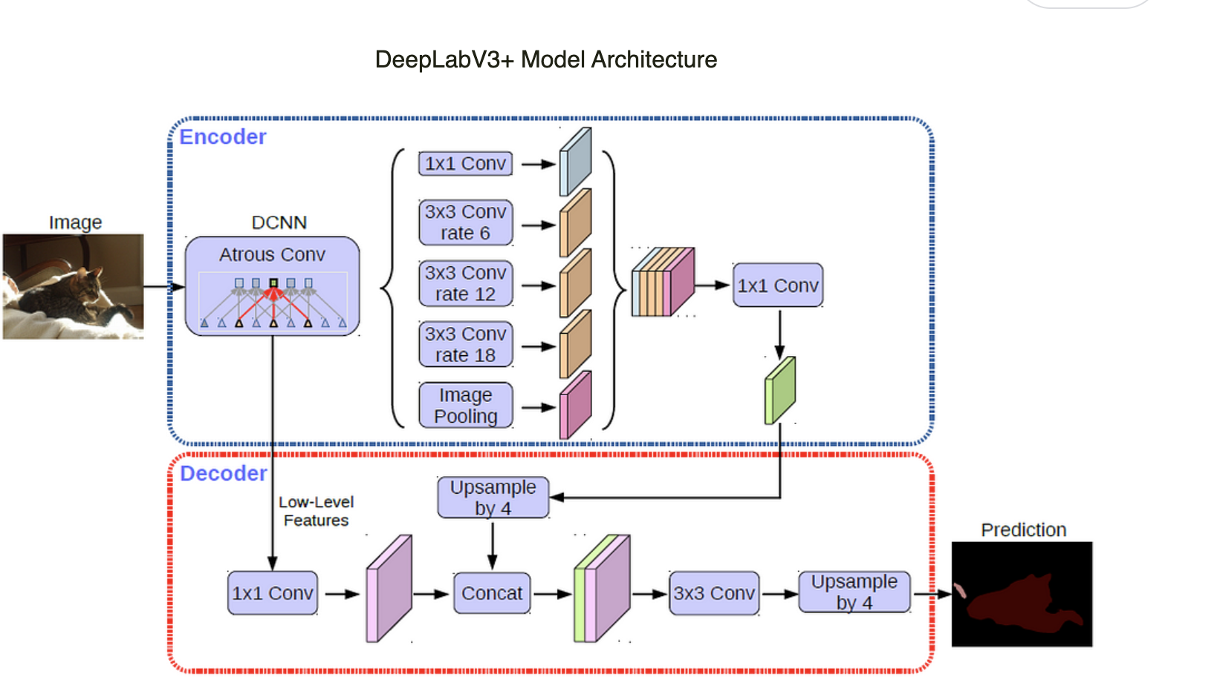

Fig 1 Model of DeepLaV3+

Results

Segmentation Output:

* Binary masks highlighting road pixels (1) and non-road pixels (0).

Performance Metrics:

* IoU: Measures overlap between predicted and ground truth road masks.
* Dice Coefficient: Measures the overlap between predicted and ground truth, indicating accuracy.
* Pixel Accuracy: Overall percentage of correctly classified pixels.

Qualitative Results:

* Urban Areas: High accuracy with clear road boundaries.
* Rural/Remote Areas: Struggles with unpaved, occluded, or complex roads.

Post-Processing Enhancements:

* Morphological Operations: Improve road continuity and connectivity.
* Graph Neural Networks (GNNs): Enhance road network topology.

Hypothetical Example Results:

* Urban Road: IoU: 0.85, Dice: 0.91, Pixel Accuracy: 94%.
* Rural Road: IoU: 0.72, Dice: 0.82, Pixel Accuracy: 88%.

Challenges:

* Class Imbalance: Roads are a small fraction of the image, leading to false predictions.
* Unpaved Roads: Struggles with differentiation in rural areas.

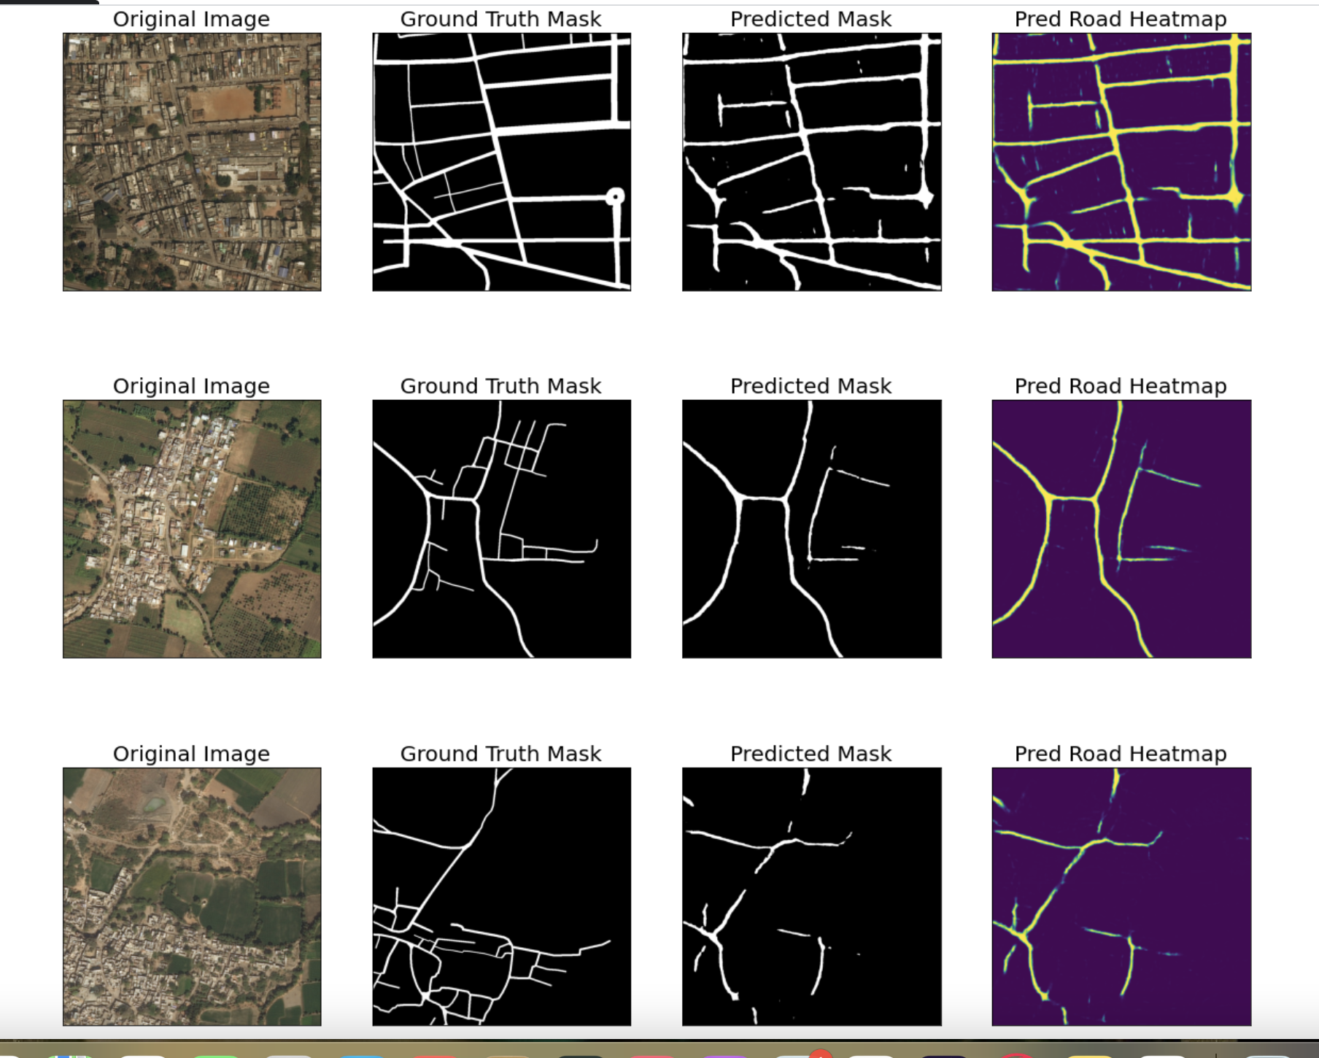

Fig 3 IoU Score Plot 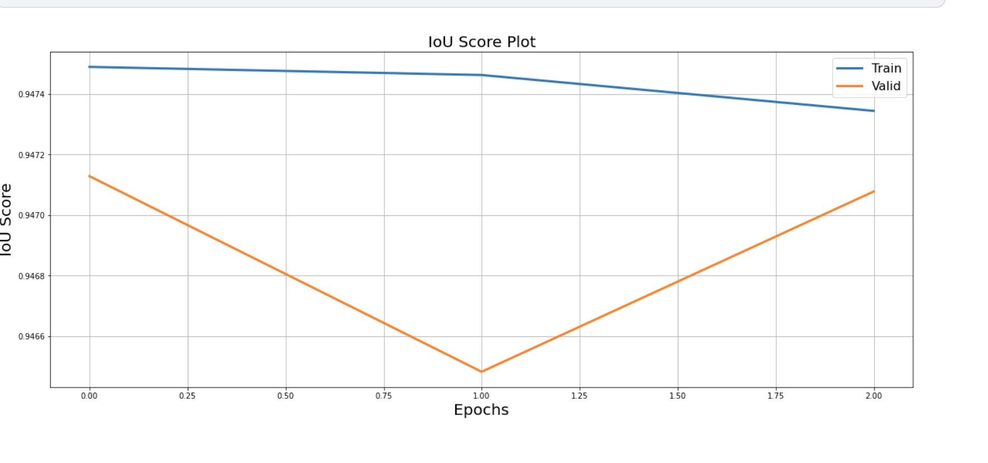

Fig 4 Dice Loss Plot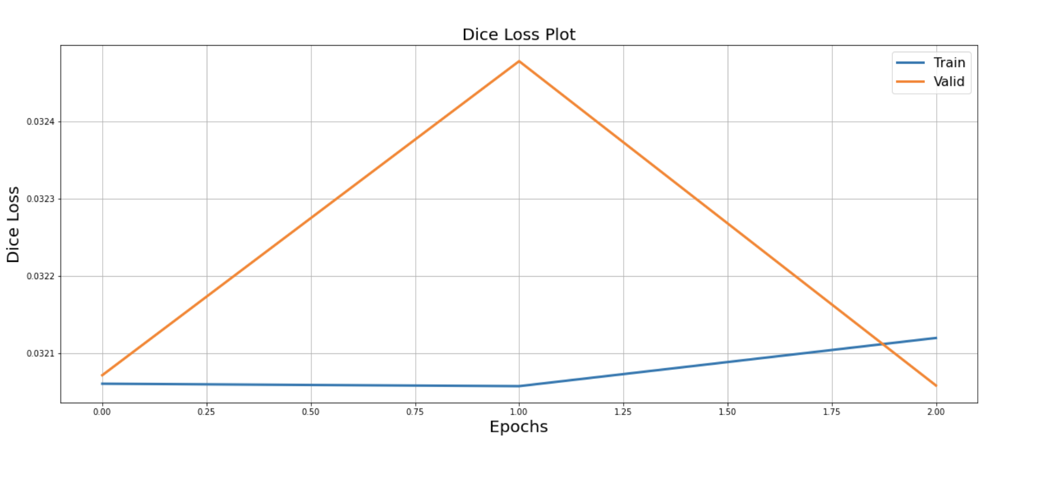

Conclusion

While traditional and machine learning-based methods have paved the way for road extraction, Deep Learning models, particularly DeepLabV3+, have proven to be the most effective approach, significantly advancing the state-of-the-art in satellite-based road segmentation. With the integration of data augmentation, hybrid approaches, and graph-based refinements, these models offer a promising solution for accurate and efficient road extraction, even in challenging environments.

The proposed system for detecting human-induced changes in satellite imagery leverages advanced AI/ML techniques to address the limitations of traditional methods. By incorporating semantic segmentation, the system accurately classifies each pixel in the satellite images, adapting to varying environmental conditions and providing robust results. Through the integration of change detection and route optimization, this system can significantly contribute to informed decision-making and the promotion of environmentally responsible practices.

References

1. Chen, L.-C., Papandreou, G., Kokkinos, I., Murphy, K., & Yuille, A. L.  
   *DeepLab: Semantic Image Segmentation with Deep Convolutional Nets, Atrous Convolution, and Fully Connected CRFs.*IEEE Transactions on Pattern Analysis and Machine Intelligence, 2018.
2. Chen, L.-C., Zhu, Y., Papandreou, G., Schroff, F., & Adam, H.  
   *Encoder-Decoder with Atrous Separable Convolution for Semantic Image Segmentation.*ECCV, 2018.
3. SpaceNet Challenge  
   Dataset and benchmarks for road and building extraction from satellite imagery.

DeepGlobe Road Dataset  
A dataset designed for road segmentation tasks in rural and urban areas.

1. Mnih, V., & Hinton, G.  
   *Learning to Detect Roads in High-Resolution Aerial Images.*ECCV, 2010.
2. Ronneberger, O., Fischer, P., & Brox, T.  
   *U-Net: Convolutional Networks for Biomedical Image Segmentation.*MICCAI, 2015.
3. Zhou, B., Wang, A., & Xu, L.  
   *Road Network Extraction Using Deep Learning and Graph-Based Methods.*ISPRS Journal of Photogrammetry and Remote Sensing, 2021.
4. Post-Processing for Road Network Extraction  
   Techniques for improving road continuity in segmentation outputs using morphological and graph-based approaches.

These references provide a foundational understanding of semantic segmentation, road extraction, and the application of DeepLabV3+ for satellite imagery analysis.

